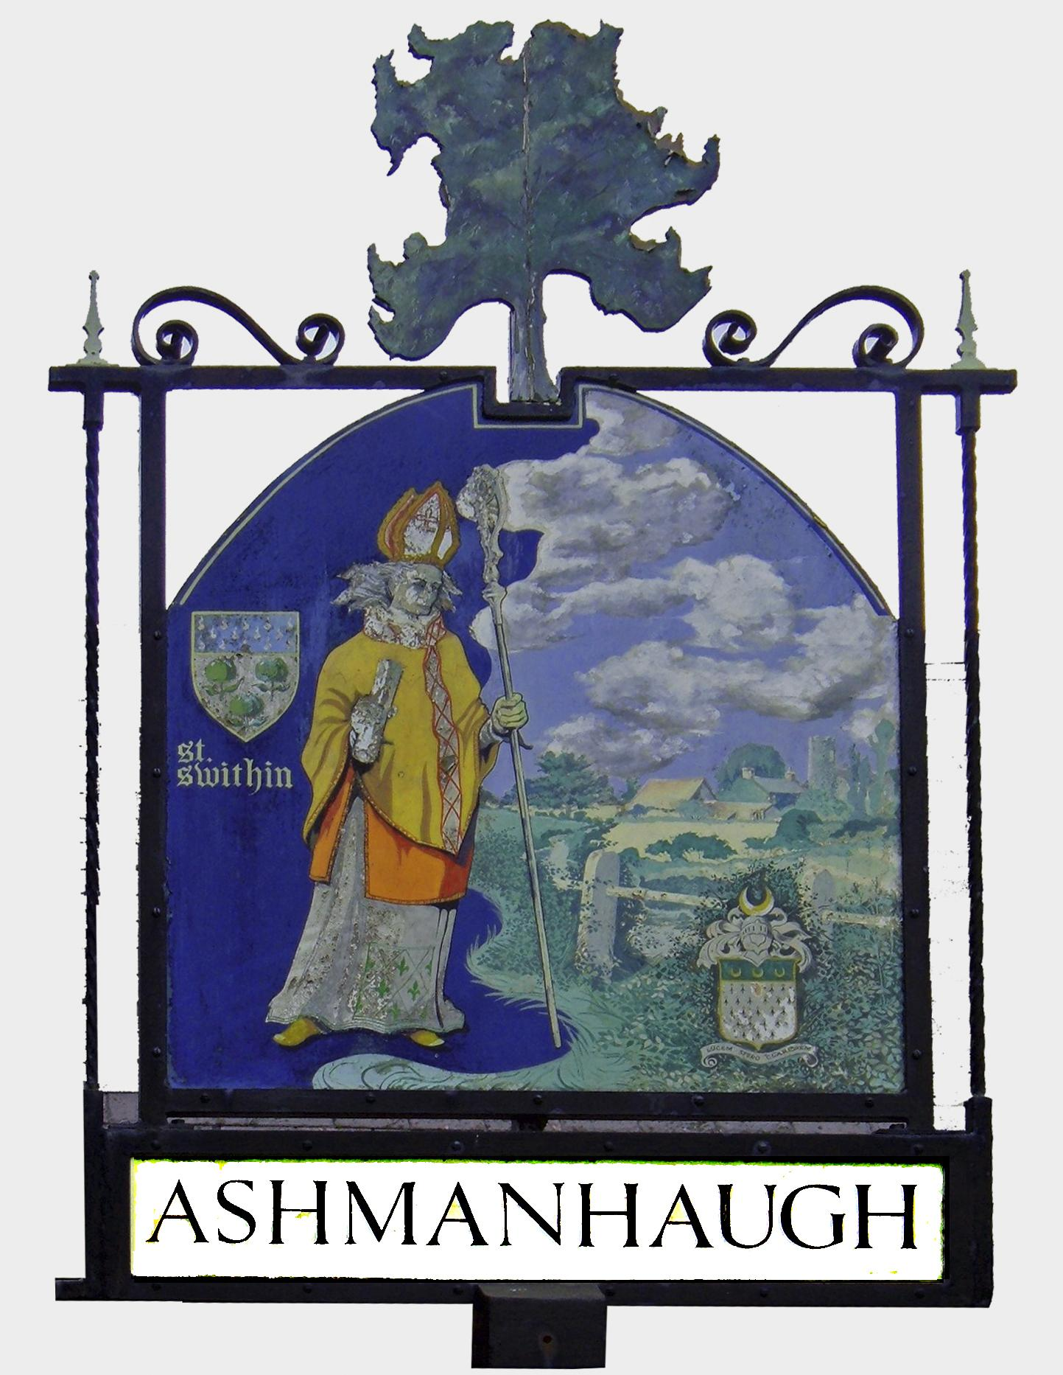
NOTICE OF PARISH COUNCIL MEETING

You are hereby summoned to attend the Ashmanhaugh Parish Council Meeting in the Preston Room on:

Tuesday 1st November 2016 7.00pm
Members of the press and public are invited to attend

AGENDA

- ATTENDANCE
To note those present and consider apologies for absence.

- DECLARATIONS OF INTEREST AND DISPENSATIONS
Members are invited to declare a previously undisclosed interest relating to items on the agenda and to ask for a dispensation to vote on matters in which they have a disclosable pecuniary interest or other non-financial interests.

- MINUTES OF PREVIOUS MEETING
To confirm the accuracy of the minutes of the Parish Council meeting held on 6th September 2016.

- PUBLIC SPEAKING
  - To receive report from County and District Councillor Nigel Dixon
  - To receive report from PCSO Jeanette Boardman.
  - To receive questions from the public relating to local issues. In line with the Parish Council Standing Orders, each speaker is allowed a maximum of 5 minutes. Maximum time allowed 15 minutes in total.

- MATTERS ARISING
  - To discuss correspondence received since the agenda was issued.
  - To receive a report on any matter not covered on the agenda.

- CORRESPONDENCE
  - Invitation to attend an event on developments in dementia care and support in Norfolk, Norfolk Health and Wellbeing Board - 20th October, 9.30am.
  - NNDC North Norfolk Local Plan - summer update.
  - Letter from Gavin Barwell MP on the new Neighbourhood Planning Bill.
  - Office of the Police and Crime Commissioner - update on the Police and Crime Plan 2016-2020 introducing the seven strategic aims.
  - Precept Consultation on change to the law allowing Government to trigger referendums on the rate of individual Parish Council's precept.
  - Mobile library times - added to notice board and website (and addendum).
  - Mind out for each other - road safety campaign launched by Norfolk Police.
  - NNDC - consultation on the Draft Sustainability Appraisal Scoping Report - deadline 21 November 2016.
  - Community Action Norfolk - invitation to attend an event on Community Land Trusts - Enabling Affordable Housing - 4th November, Cromer.
  - Broads Authority - consultation on the Broads Plan 2017 - deadline 30th December.
  - Invitation to attend the Norfolk ALC AGM Saturday 26th November, 10am, East Tuddenham.

- HIGHWAYS, PLANNING, LAND AND ASSET ISSUES
  - Presentation and discussion with Mark Ashwell, Planning Policy Advisor from NNDC on the new Local Plan, housing allocations in rural villages and the lack of affordable housing in Ashmanhaugh.
  - To note no planning applications were received in the period.
  - To note the letter from Justin Le May, Highways, NCC regarding the Ashmanhaugh crossroads. To discuss cutting back of trees and shrubs in the area.
  - To note that a further repair has been made to Church Road by Highways, NCC.
  - To discuss and vote whether to relaunch the Homewatch scheme, following the presentation by Peter Evans, Homewatch Coordinator at the last meeting. VOTE
  - To review Defibrillator quotes and discuss possible locations and funding. To agree way forward.
  - The Common - to agree the public meeting minutes and proposals. To sign off the specification for works. To discuss the Clerks meeting with the Cricket Club (27th October).
  - Village Sign - Jason Greenberry, local blacksmith is undertaking repairs to the frame at cost. To review signwriters quote. To agree on proceeding with the works. VOTE
  - BT Phone Box - correspondence from NNDC and BT regarding the removal of working boxes across Norfolk. To discuss and VOTE on possible adoption of the phone box, should BT advise that the Ashmanhaugh phone box is being decommissioned. VOTE

- ADMINISTRATIVE MATTERS
  - Newsletter - to discuss if the Parish Council intends to make a financial contribution to the printing of the Church newsletter. To note a refund is required to WiSpire for 6 months unfulfilled advertising.
  - Norfolk ALC - to note the new training programme.

- FINANCIAL MATTERS
  - To review this period's financial position
    - To receive and sign Bank Reconciliation – current balance £7897.21.
    - To note receipts of:
      - NNDC Precept and grant £1800.00
    - To authorise payments for:-
      - Clare Male – salary Sept/Oct £334.43
      - Clare Male – expenses £26.99
      - Clare Male - mileage £10.58
      - WiSpire - refund for 6 months advertising £15.00
    - To note that cheque issued to N Sharpe for the newsletter in September has been cancelled.
  - To review and agree the revised budget forecast, asset register and precept figures for 2017-2020. VOTE.

- POLICIES
  - To review Calendar of Parish Council meetings 2017.
  - To review Model publication scheme (FOI).

- ITEMS FOR NEXT AGENDA - Tuesday 3rd January 2017 at 7.00pm

Published: 26th October 2016

Clare Male
Clerk & RFO to the Parish Council
ashmanhaughparishcouncil@gmail.com
07803 705434

