Ashmanhaugh and Barton Wanderers Cricket Club

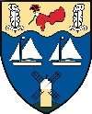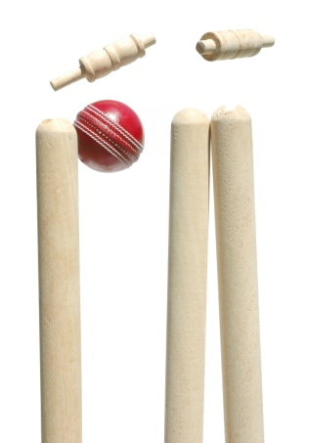

www.abwanderers.org.uk

Ashmanhaugh and Barton Wanderers Cricket Club,
Barton Turf Ground, Hall Road, Barton Turf,
Norwich, NR12 8AU
And
Ashmanhaugh Ground, Church Road, Ashmanhaugh Norwich NR12 8YL
For further info please contact : darren.marrable@abwanderers.org.uk

